附件1

新加坡原产地证书
（样本）

1.出口商(名称及地址) | 新加坡共和国  优惠原产地证书  证书号码：  未经授权不得对本证书内容进行增改
2.收货人(名称、地址及国家) | 新加坡共和国  优惠原产地证书  证书号码：  未经授权不得对本证书内容进行增改
3．启运日期 | 8. 出口商声明  兹申明本证书上的内容及说明正确无误。  签名:  姓名:  职称:  日期: 签章
4. 船舶名称/飞机航班号码 | 8. 出口商声明  兹申明本证书上的内容及说明正确无误。  签名:  姓名:  职称:  日期: 签章
5. 卸货口岸 | 8. 出口商声明  兹申明本证书上的内容及说明正确无误。  签名:  姓名:  职称:  日期: 签章
6. 最终目的地国 | 8. 出口商声明  兹申明本证书上的内容及说明正确无误。  签名:  姓名:  职称:  日期: 签章
7. 货物原产国 | 8. 出口商声明  兹申明本证书上的内容及说明正确无误。  签名:  姓名:  职称:  日期: 签章
9 .唛头及编号 10 . 包装号码及种类 11. 数量及单位
商品描述

(必要时包括品牌)
12． 主管机构证明

兹证明, 上述资料足以证明上述货物原产于第7栏所述的国家。

新加坡签发优惠原产地证书的填制说明
序号 | 描述 | 所需信息
1 | 出口商 | 新加坡出口商的中央注册号、姓名和地址。中央注册号是新加坡海关向进出口企业签发的唯一编号。
2 | 收货人 | 中国收货人的姓名和地址。
3 | 启运日期 | 船舶或飞机的离港日期。
4 | 船舶名称/飞机航班号 | 船舶的名称或飞机的航班号码。
5 | 卸货口岸 | 货物卸载的最终目的港。如货物经过转运, 航线的其他详细信息应在第10栏中列出, 或作为本证书的附页。
6 | 最终目的国 | 中国应为货物的最终目的国。
7 | 货物的原产国 | 货物的原产国应为新加坡。
8 | 出口商声明 | 出口商应在此栏中签名。
9 | 唛头及编号 | 货物的唛头及编号, 必要时可作为附页。
10 | 货物包装号码及种类; 商品描述 | 应在此栏中报明以下信息:  • 出口货物的商品描述，应和发票所列产品的商品描述相一致。准确的商品描述将有助于最终目的国海关加快货物通关。  • 每项货物的《协调制度》6位数子目。  • 每项货物的相应原产地标准 。  • 发票的编号和日期。根据第五章(海关程序)第36条(第三方发票)的规定, 由驻在非缔约方的公司或者在出口方为该公司代销的出口商开具。
11 | 数量及单位 | 货物的数量及其计量单位(如件、公斤等) 。
12 | 主管机构证明 | 出口方授权机构的签章。
 | 证书编号 | 出口方授权机构对所签发的每一份证书的唯一编号。

Singapore’s Certificate of Origin

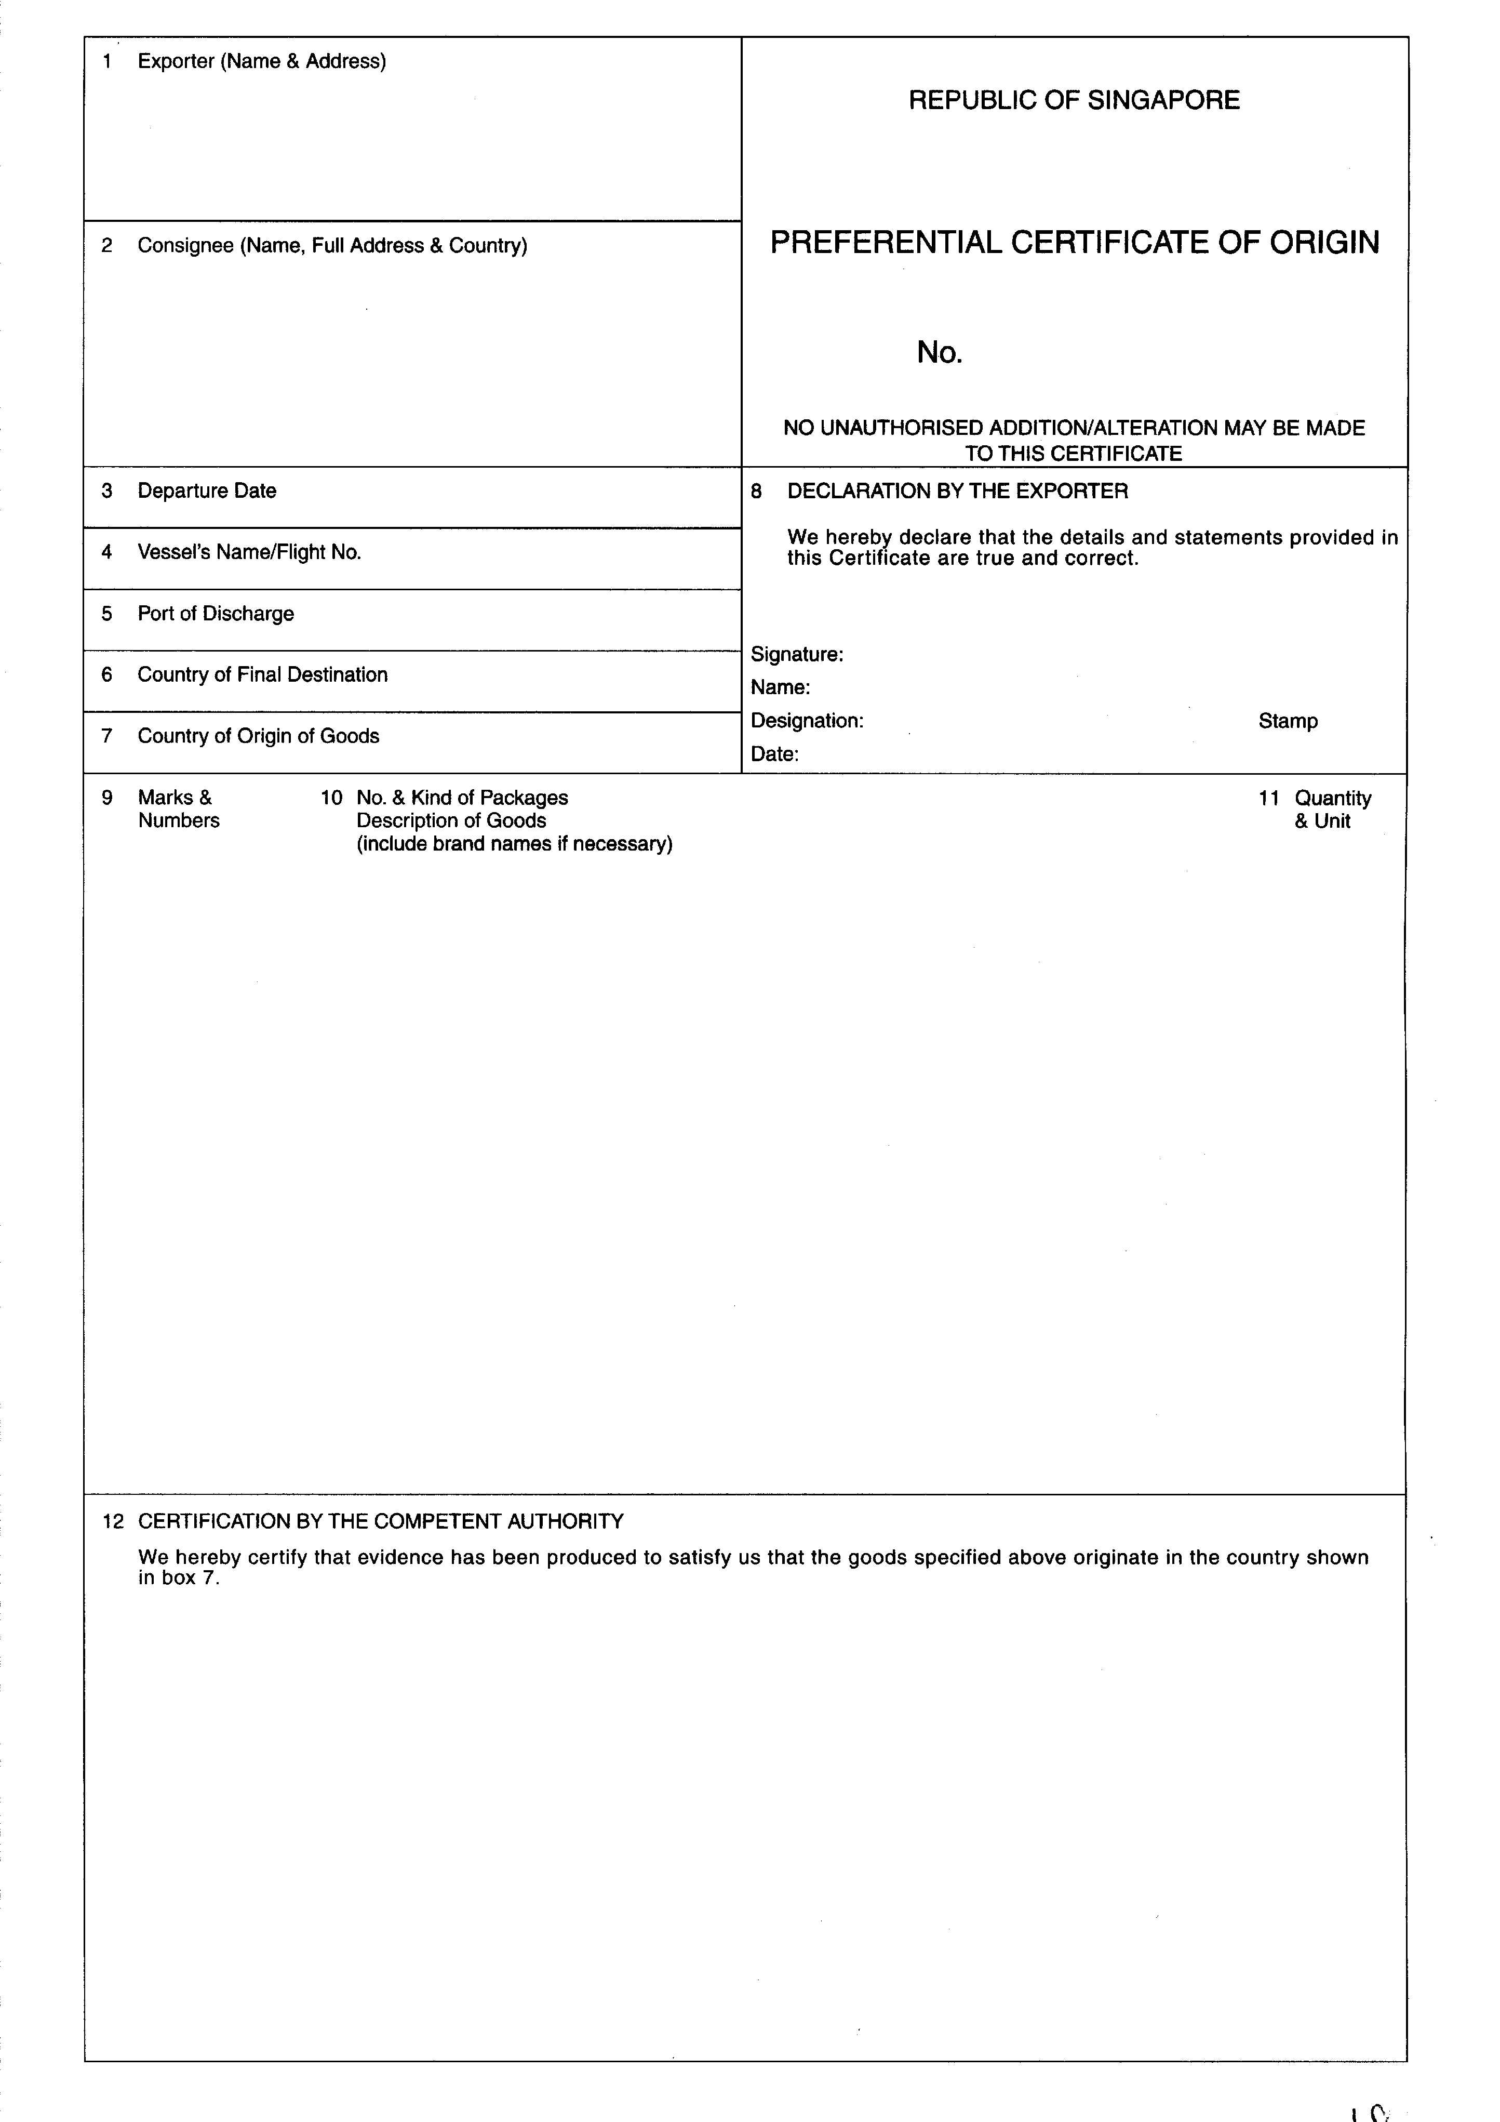

EXPLANATORY NOTES TO THE FORMAT OF PREFERENTIAL CERTIFICATE OF ORIGIN ISSUED BY SINGAPORE
Box  No. | Description | Type of Information Required
1 | Exporter | The Central Registration Number, name and address of the exporter in Singapore. The Central Registration Number is a unique number issued by Singapore Customs to companies which intend to import or export.
2 | Consignee | The name and address of the importer in China.
3 | Departure Date | The departure date when the vessel/aircraft left port/airport.
4 | Vessel’s Name/Flight No. | The vessel’s name or the aircraft flight number.
5 | Port of Discharge | The final port in which the goods will be discharged. Where goods are transshipped, the additional details of the route may be declared in box 10 or in a separate attachment to this Certificate.
6 | Country of Final Destination | The country of final destination will be China.
7 | Country of Origin of Goods | The country of origin must be Singapore.
8 | Declaration by the Exporter | The exporter will sign in this box.
9 | Marks & Numbers | The marks and numbers of the goods, to be attached in separate sheet, where necessary.
10 | Number & Kind of Packages; Description of Goods | The following information will be declared in this box:  •  The description of the products exported. This should be identical to the description of the products contained in the invoice. An accurate description will help the Customs Authority of the country of destination to clear your products quickly.  •  The 6-digit HS subheading for each product.  •  The relevant origin criterion for each product.  •  Number and date of invoices, issued either by a company located in a non-Party or by an exporter in the exporting Party for the account of the said company, as referred to in Article 36 (Third Party Invoicing) in Chapter 5 (Customs Procedures).
11 | Quantity & Unit | The quantity and its unit of measurement (such as pieces, kg) of the goods.
12 | Certification by the Competent Authority | Seal or stamp of the authorised body of the exporting Party.
 | Certificate Reference Number | A unique number will be assigned to each Certificate issued by the authorised body of the exporting Party.

