Procedural Guidelines for Requesting Accelerated Patent Decision
Under the Cooperation for Facilitating Patent Grant of the Laos-related Patent Application
between the Patent Office of the China National Intellectual Property Administration and the Department of Intellectual Property of the Ministry of Science and Technology of Lao People's Democratic Republic

Applicants can request accelerated decisions on patents in Laos for patent applications that they have filed with the Department of Intellectual Property (DIP), Ministry of Science and Technology of Lao People's Democratic Republic (hereinafter referred to as “the DIP patent applications”), which meet the following requirements based on their prescribed procedures, including related documents, under the Cooperation for facilitating Patent Grant of Laos-related patent application (hereinafter referred to as “the CPG”) that uses examination results of patent applications filed with the National Intellectual Property Administration of People’s Republic of China (CNIPA).
The applicants can file a CPG application with DIP any time before the patent is granted.
In requesting accelerated patent decision based on the CPG, applicants must submit a request form to the DIP.
Whenever it is deemed necessary to either modify the CPG or terminate the CPG due to reasons such as the number of requests for accelerated patent decisions based on the CPG exceeding a manageable level or other reasons, Ex Ante notice will be published.

1. Requirements for Making Requests
(a) Both the DIP patent application on which CPG is requested and the Chinese patent application (hereinafter referred to as the corresponding CNIPA patent application) forming the basis of the CPG request shall have the same earliest date (whether this be a priority date or a filing date).
The DIP patent application must be one of the following:
Case I: A patent application (including a PCT national phase application) validly claiming priority under the Paris Convention based on the corresponding CNIPA patent application. (Examples are provided in Figure A, B, C, D, E and F);
Figure A: Paris route
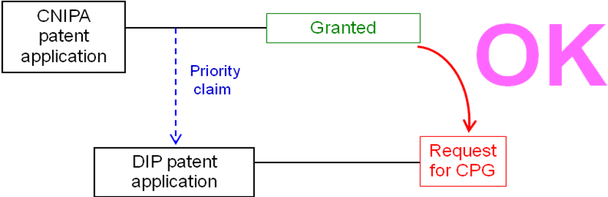
Figure B: PCT route
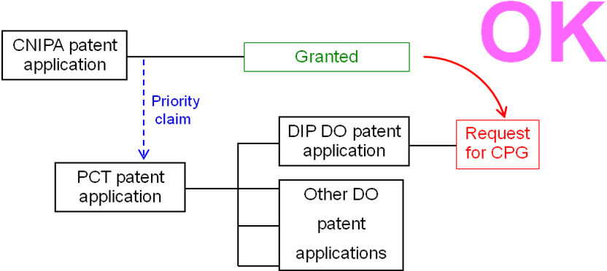
Figure C: Paris route, Domestic priority
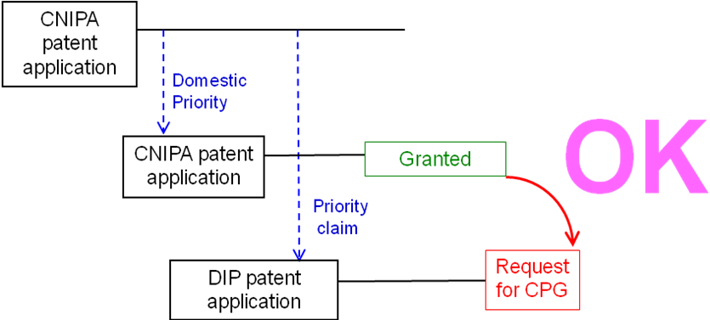
Figure D: Paris route & Complex priority
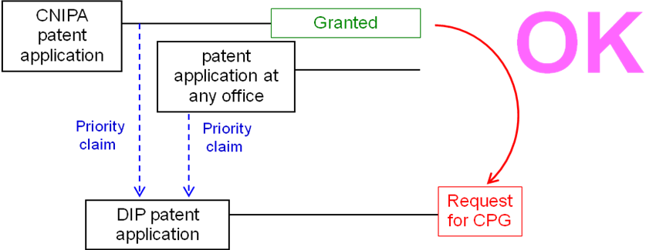
Figure E: Paris route & divisional patent application
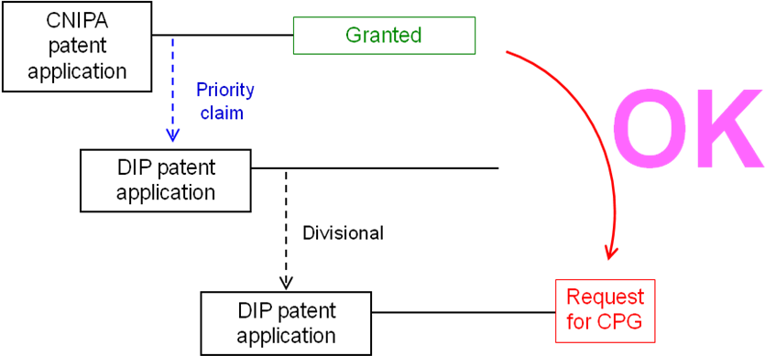
Figure F: PCT route
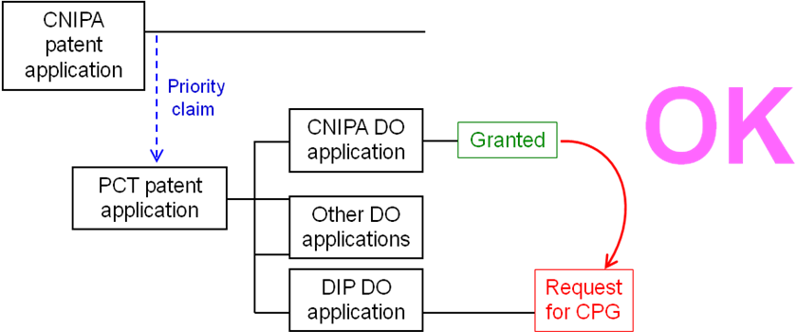

Case II: A patent application that serves as the basis for validly claiming priority under the Paris Convention of the corresponding CNIPA patent application (including a PCT national phase application) (Examples are provided in Figure G and H);
Figure G: Paris route
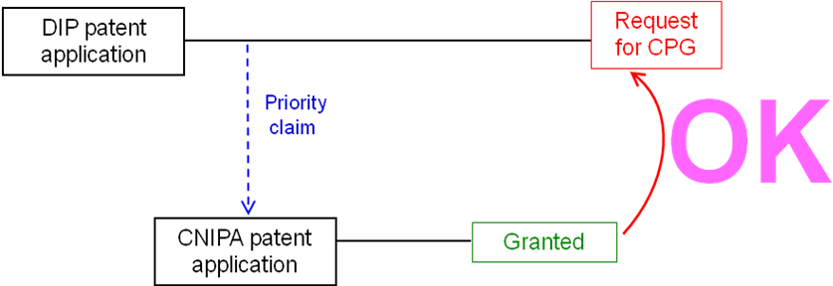
Figure H: PCT route
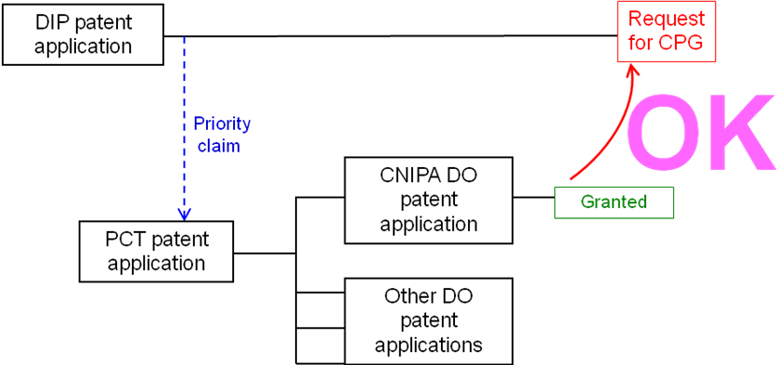

Case III: A patent application that is based on the same patent application for claiming priority under the Paris Convention, as the corresponding CNIPA patent application (including a PCT patent application that entered the national phase.) (Examples are provided in Figure I, J, K, L and M);
Figure I: Paris route, but the first patent application is from the third country
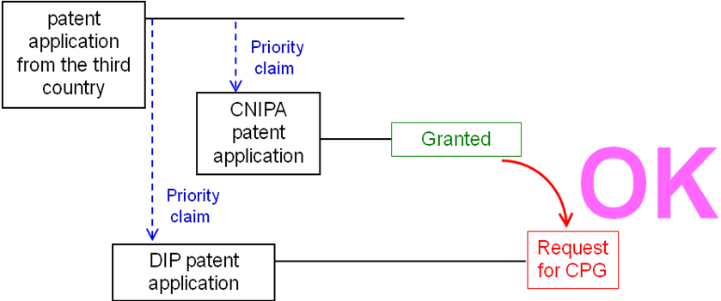
Figure J: PCT route, but the first application is from the third country
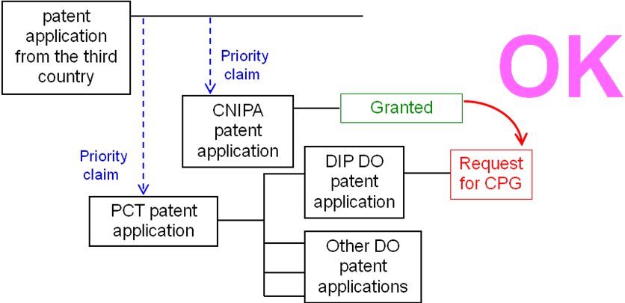
Figure K: Direct PCT & Paris route
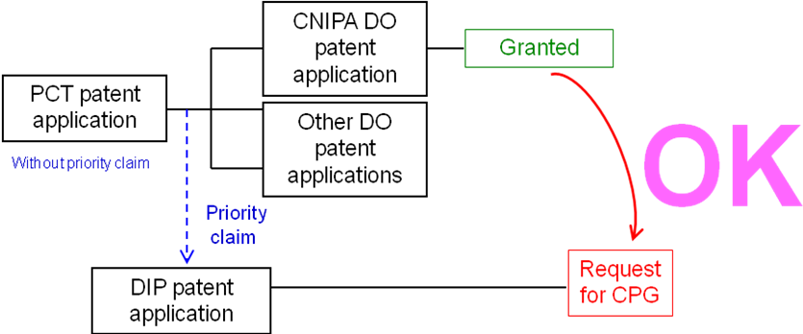
Figure L: Direct PCT & PCT route
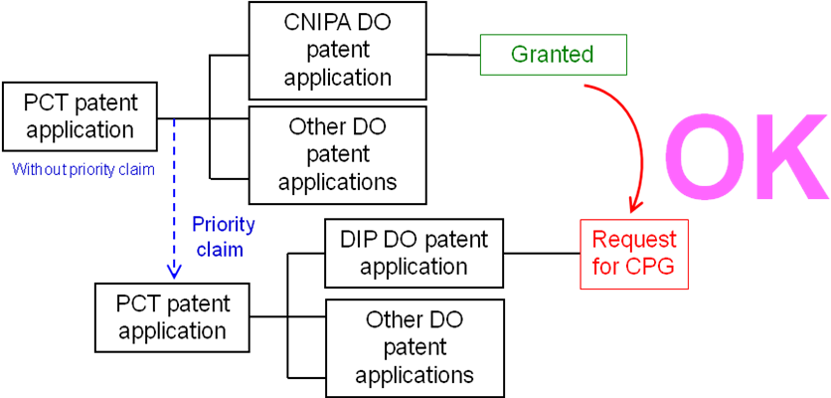
Figure M: Direct PCT & PCT route
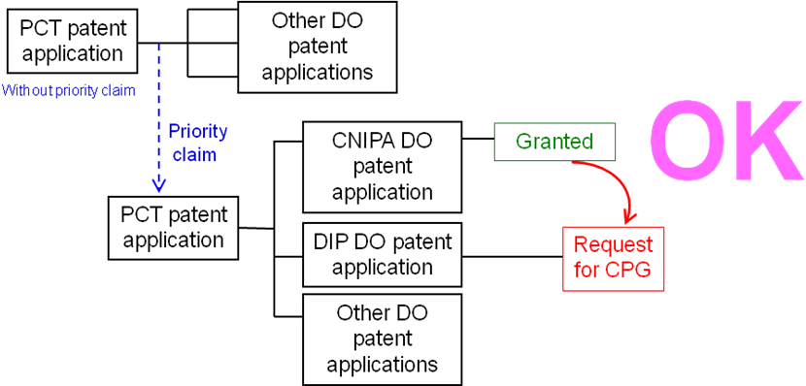

Case IV: A PCT national phase application where both the corresponding CNIPA patent application and the DIP application are derived from a common PCT international application having no priority claim (Example is provided in Figure N).
Figure N: Direct PCT route
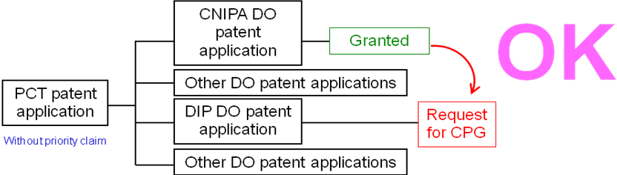

(b) The corresponding CNIPA patent application has been granted by the CNIPA

(c) All the claims in the DIP patent application requesting accelerated patent decision based on the CPG have been amended as required, so that the claims are the same as one or more claims in the corresponding CNIPA patent application granted by the CNIPA
Applicants are allowed to delete a part of the claims that were granted by the CNIPA (Such claims will be considered to be “the same”). However, when claims are deleted, it is necessary to state the claims on the “claims correspondence table” in a way that shows the correspondence between the claims granted by the CNIPA and the claims in the DIP patent application.
It should be noted that a claim in the DIP which introduces a new/different category of claims to those claims granted in the CNIPA is not considered as being the same.

2. Documents to be Submitted
The following documents (a) to (d) must be submitted within two (2) months after the date on which the request was filed for the CPG:
(a) A copy of the patent gazette in the corresponding CNIPA patent application
(b) A duplicate copy of patent register of the corresponding Chinese patent.
(c) A translation of Claims and Specification described in the patent gazette in English and in Lao.
Applicants must submit a translation in Lao within three (3) months of the date on which the request was filed for the CPG.
(d) Claims Correspondence Table
Applicants must submit a claims correspondence table that shows the correspondence between all the claims in the DIP patent application and all the claims in the corresponding CNIPA patent application that were granted.
When the number for the claims granted by the CNIPA and the number for claims in the DIP patent application have become misaligned due to the deletion of claims, applicants are requested to state the claims in a way that clearly shows the correspondence between the claims granted by the CNIPA and the claims in the DIP patent application.
(e) Amendment of the claims
In the case where the DIP patent application requesting accelerated patent decision based on the CPG does not meet item (c) of paragraph 1 (“Requirements for Making Requests”), applicants must submit the amendment of the claims to meet the requirement. The claims could be amended for multiple times.

3. Procedures of accelerating patent decision under the CPG
Upon the receipt of CPG request and relevant documents, the DIP will decide whether to accelerate patent decision for the patent application under the CPG or not. Once the CPG request is approved, the DIP will grant the patent under the CPG as soon as possible without written notification to the applicant.
Where a CPG request fails to meet the above-mentioned requirements, the applicant will be notified by the DIP on such failure and the flaws existing in the CPG request. The CPG request could be amended for multiple times to meet relevant requirements.

Note: When applicants request accelerated patent decision based on the CPG within 32 months from the filing date or the priority date, the Documents submitted for the CPG shall be treated as the copy of the report on search or examination by another authority provided in article 41, Law of Intellectual Property of Laos.
3. Request form

Subject: Request for an accelerated patent decision under the CPG

Date of filing:

Patent Application number:

Title of the invention:

Applicant:

Corresponding CNIPA patent application number:

Attached documents

A copy of patent gazette in the corresponding CNIPA patent application

A duplicate copy of patent register of the corresponding Chinese patent

Translation of Claims and Specification described in the patent gazette in English

Translation of Claims and Specification described in the Patent gazette in Lao
(Note) Applicant may submit this translation within three (3) months of the date on which the request for the CPG was filed.

Claims correspondence table

Amendment of the claims (where required)

Claims correspondence table
The claim  in the DIP | The granted claim in the CNIPA | Comments about the correspondence

The claim  in the DIP | The granted claim in the CNIPA | Comments about the correspondence
1 | 1
2 | 2
3 | 5 | Claim 3 is the same as the granted claim 5 in the CNIPA. Granted Claims 3 and 4 in the CNIPA have been deleted.
4 | 6 | Claim 4 is the same as the granted claim 6 in the CNIPA. Granted Claims 3 and 4 in the CNIPA have been deleted.

